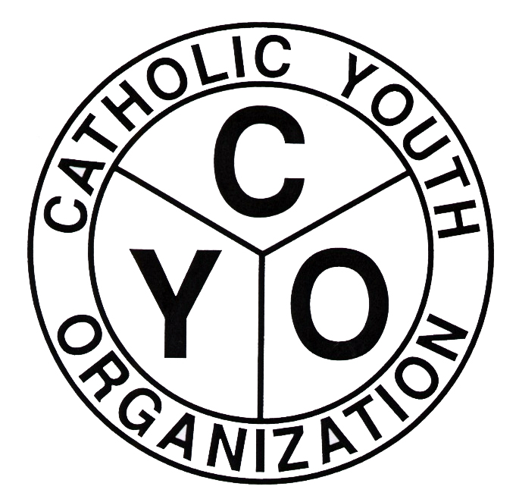
CATHOLIC YOUTH ORGANIZATION
Diocese of Brooklyn
7200 Douglaston PKWY – Douglaston, NY 11362
Tel: 718.281.9548/Fax: 718.281.9557

2016-2017 CYO SWIMMING POST SEASON CELEBRATION

THE PARISH OF______________________________________________HAS ENTERED A TEAM IN THE 2016/2017 SWIMMING LEAGUE SPONSORED BY CYO.
BOYS_____________ GIRLS ___________________
TEAM NAME ____________________________________________________________
HEAD COACH'S NAME_____________________________________________________
ADDRESS_______________________________________________________________
HOME PHONE#_________________ CELL #______________________ E MAIL ____________________
**********************************************************************

ONE CHECK FOR $150 PAYABLE TO CATHOLIC YOUTH ORGANIZATION FOR THE COSTS INVOLVED FOR THE POST SEASON COACHES CELEBRATION SHOULD BE RETURNED TO KATHY KIRKER BY:
- BOYS TEAMS – OCTOBER 21, 2016
- GIRLS TEAMS – JANUARY 20, 2017

KATHY KIRKER, CYO SWIMMING COORDINATOR
CATHOLIC YOUTH ORGANIZATION
126 Beach 207th Street
Rockaway Point, NY 11697

Revised 9/21/16

